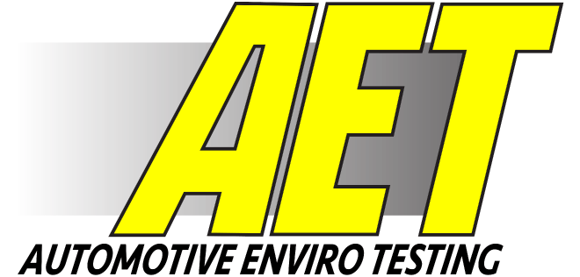
SITE OPERATING RULES
& REGULATIONS

Updated Nov. 2022
Building and Common Areas

- All persons seeking entry into the AET facility will first require clearance and need to register as a customer (tester) or sign in on the AET Daily Visitor Entry Log as a visitor.

- Customers (testers) will be required to read and individually sign the Facility Registration and Agreement form prior to entering the AET facility.

- All registered customers (testers) have autonomy to leave and return to the site without additional check ins. However, they as individuals will check out with AET on conclusion of their stay, regardless of whether other members of their group remain on site.

- All visitors will sign out on the AET Daily Visitor Entry Log upon leaving the site.

- Customers will not transport, accompany or in any way assist site entry of any person not cleared and registered as a customer or visitor with AET.

- Registered customers will be assigned a site entry code exclusive to their group. This code number can be applied to the entry keypad and enable the site entry gate to open and automatically close. It is a violation of these rules to convey assigned code numbers to any other person.

- Registered customers renting building(s) will be given a visitor card to gain access to their assigned building(s).

- No customer (tester) or visitor shall enter or attempt to enter any building inside the main access gate unless that building has been expressly assigned to that customer or by invitation of the Site Coordinator.

- No customer (tester) or visitor shall attempt to observe or survey any other customer’s products, tests, or operations.

- Use of cameras and photographic equipment will be allowed within the customers assigned building(s), in the site building area and on the test courses when no other customers are present with approval from the AET Course Coordinator

Use is prohibited in site building areas and site test courses when more than one customer is cohabitating that area of the site. Special exceptions may be possible only through the AET Course Coordinator and then only if he/she can satisfy all customers security concerns.

ANY PHOTOPGRAPHY OF ANOTHER CUSTOMER’S (TESTER’S) PRODUCT, TESTS OR OPERATION IS PROHIBITED AND STRICTLY A VIOLATION OF THESE RULES AND REGULATIONS. ALL FILM IN THE VIOLATOR’S POSSESSION WILL BE CONFISCATED BY AET PERSONNEL, AND THE VIOLATOR SUBJECT TO EJECTION FROM THE AET FACILITY.

- Customers (testers) shall be liable for repair costs of negligent damage they may cause to AET buildings or equipment.

- All AET buildings are smoke free, including lodging. There are smoking areas in front of each customer garage and housing unit.

- Building area speed limit shall be at a safe speed relative to driving conditions, but not to exceed 15 mph.

Test Course Area Use

- Any vehicle(s) on the test course grounds must have an AET radio on board and be monitoring Channel 1. Channel 1 is the main channel for course information, updates, and contact with AET Maintenance and the AET Course Coordinator.

- The bridge and approaches to the test course area are single lane only. Do not meet another vehicle on the bridge. The bridge and approach speed limit shall be at a safe speed relative to driving conditions, not to exceed 5 mph.

- No customer shall enter the test course area without having been assigned test courses and times by their groups On-site coordinator that were approved through the AET Course Coordinator.

- Usage of approved asphalt courses during and after periods of snowfall must also be coordinated with AET Maintenance. Courses effected are #12, #14 and #16. Contact AET Maintenance with the radio on Channel 1 prior to entering these courses to ensure they are cleared and available. Failure to do so may result in damage to the course(s) that could take several days to repair and delay further testing.

- Any use or testing of tire chains must first be approved by AET. This includes AET building areas.

- No customer shall enter test courses he/she has not been authorized to use at that time. All access questions or concerns should be directed to the AET Course Coordinator with the radio on Channel 1.

- Each course is identified with a sign at its entry point. Each sign further displays either a green “OPEN” or red “CLOSED” panel. Never enter a course when the red “CLOSED” panel is displayed. Course #18, “Camber Course,” is line of sight hindered, therefore anyone using this course must deploy the “CLOSED” sign when entering. If you have been approved to use a course but the red “CLOSED” sign is displayed, please contact AET Maintenance on Channel 1 for further direction.

- Familiarize yourself with the courses, signage, and flagging at low speeds prior to testing. The AET Course Coordinator is available daily and can answer any questions and/or provide course tours. Use the Radio on Channel 1.

- Always observe and obey all course signs.

- All drivers and passengers must wear seat belts while operating vehicles.

- Test vehicles must stay on course. Do not attempt to go “cross country”. Course area perimeters are extremely dangerous near the river and its associated terrain.

- All test vehicles must operate on all courses according to the established clockwise traffic pattern.

- All headlights, taillights, turn signals, brake lights and windows shall be free of snow, ice, and frost.

- Vehicle flashers may be utilized on test vehicles operating on any test course.

- Vehicle headlights will be on during periods of low visibility and prior to dusk.

- All test drivers and passengers should have adequate cold weather protective clothing with them while testing. Should a tester have to abandon the vehicle for any reason, frostbite can occur rapidly in the sub-zero environment.

- Testers whose vehicles go off course and become stuck and/or need assistance for any reason should contact AET Maintenance using the AET radio system on Channel 1 immediately.

- Excessive speed and reckless operation of vehicles on access roads and test courses is prohibited. The AET Safety and Security team reviews camera footage and accesses the courses daily to monitor and ensure that all drivers are operating safely and within their groups daily approved courses. These members can be found on-site by identifying AET vehicles with green and white flashing lights.

- Report any observed surface damage, unsafe condition, or hazard/concern of any nature to the AET Course Coordinator immediately.

- Drivers who observe AET maintenance equipment on courses must contact AET Maintenance on Channel 1 prior to entering the course.

- Test drivers should be prepared to cease testing, without notice anytime a safety hazard appears, i.e., blowing snow or heavy snowfall which can quickly cause the “white out” effect to visibility.

- Report any accident or incident to the AET Course Coordinators/Heads of Safety and Security immediately.

Adam Gau ………. 763-248-0989(text), Radio Channel 1
Adam.aet@wiktel.com

Dallas Block …….. 218-434-1065, Radio Channel 1
Dallas8Block@gmail.com

- In the event of an EMERGENCY call:
AET 218-634-2041 or Radio Channel 1
LakeWood Hospital 218-634-2120
Baudette Clinic 218-634-1655
Ambulance 911
Fire 911
Police 911

SAFETY MUST BE EVERYONE’S FIRST PRIORITY AT AET

